Name: Ritanshu Mahajan
Reg No: 25MCA10077
College: Vellore Institute of Technology

ASG-Airlines-Data-Pipelines
1. Introduction

The airline industry generates a vast amount of data from day to day. This data is of different types and contains various data points about flights, passengers, and money-related activities. Some of the data may have missing values, repeated records, invalid time stamps, and other issues.
This project aims to propose a data engineering solution for ASG Airlines. The data pipeline will ensure that the company extracts data, performs data quality assessments, cleanses and transforms it, tokenizes PII information, prepares analytical datasets, and visualizes them in Power BI.

A python-based Jupyter Notebook pipeline was created and executed to accomplish the task. The solution was designed to be cloud Independent but compatible with Azure.

The final product is a dashboard in Power BI that allows users to explore the data about flights’ operations, duration, routes, bookings, and revenue.

2. Problem Statement

The raw ASG Airlines dataset has a number of data quality issues that need to be addressed before it can provide an accurate basis for business analysis.

The major problems include:

Duplicate entries
Reused/colliding flight IDs
Missing/unknown airline information
Inconsistent date/time information
Flights over midnight
Incorrect/unreliable duration values
Missing values
Duplicate passenger entries
Potentially sensitive passenger information
Inconsistent booking/payment information
Potential duration anomalies

If not properly addressed, each of these problems can cause distortions in descriptive analytics, such as average flight duration, route traffic/revenue, etc.
For this reason, the project is focused on building a complete data pipeline that would transform the raw dataset into a cleansed, validated and analytical-ready form.

3. Objectives

The objectives of the project are:

- Ingest the raw airline data set.
- Explore and analyze the source data.
- Identify missing, duplicate, and conflicting records.
- Clean and transform the raw dataset.
- Correct the flight duration calculation, including overnight flights.
- Detect any anomalous flight-duration records.
- Verify any linkages between data sets.
- Protect the passengers’ personally identifiable information.
- Produce cleansed datasets that are ready for analysis.
- Calculate key performance indicators (KPIs) relevant to the airlines’ business.
- Build a Power BI dashboard visualizing the results.
- Document the entire architecture, design, and implementation.
- Store the project files in a GitHub repository.
- And offer a scalable architecture that can be migrated to the Azure platform.

4. Dataset description

The raw dataset contains several connected airline datasets.

The main datasets used for the pipeline are presented below.

Dataset Description
Flights Flight-related information
Bookings Passenger booking information
Payments Information about payments
Passengers Information about passengers

The datasets are connected using foreign keys such as

flight_id,
booking_id,
passenger_id

The cleaned analytical model includes the following tables:

fact_flights
dim_bookings
fact_payments
dim_passengers

5. DATA FLOW
The implemented solution follows the following SCHEMA:

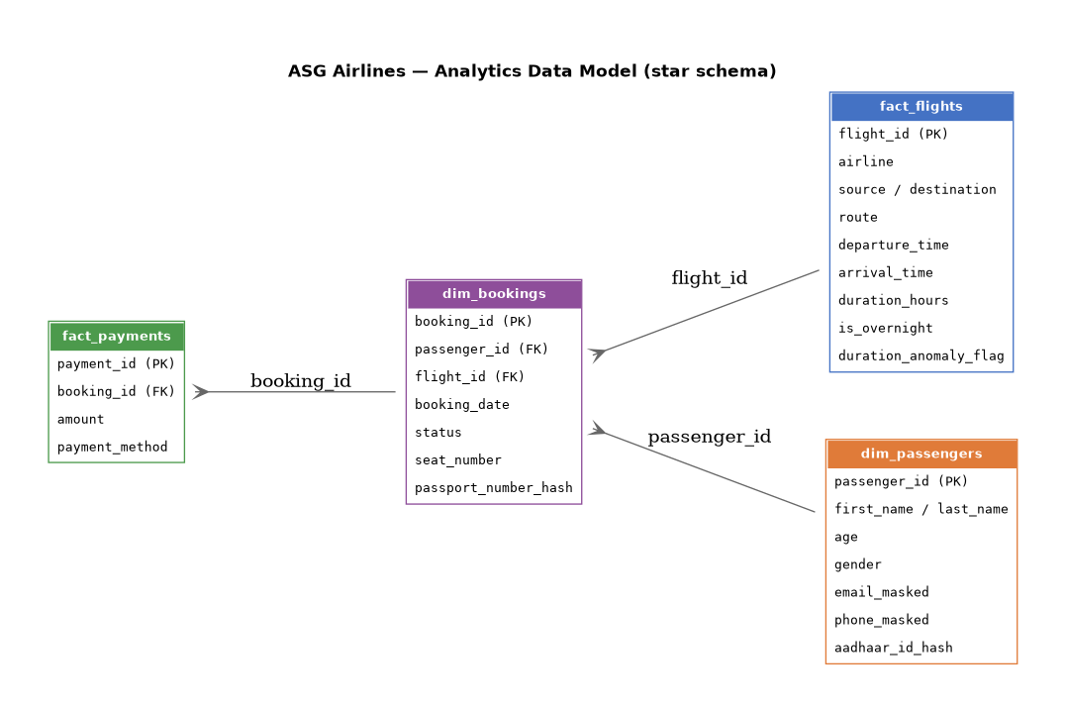
6. DATA FLOW
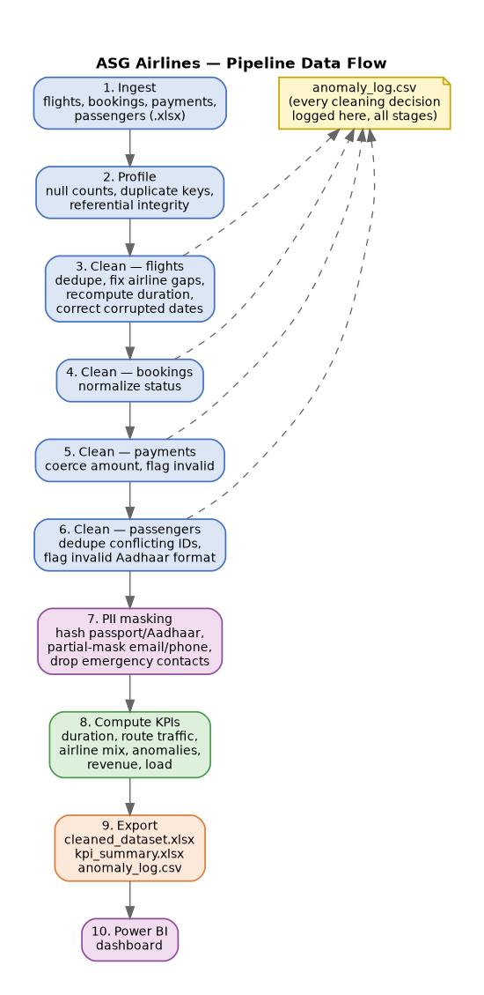
7. DATA INGESTION
The pipeline begins by loading the raw Excel workbook into Python.
Pandas is used to read the different sheets and create DataFrames for flights, bookings, payments and passengers.
The ingestion process ensures that:
- The source data is loaded reproducibly.
- Different datasets are maintained separately.
- Data types can be inspected before transformation.
- The original raw data is not modified.
- The pipeline can be executed again when required.
The complete ingestion code is available in the project Jupyter Notebook.

8. Data Quality Assessment
Data quality checks are performed before transformation.
The pipeline checks for:
8.1 Missing Values
Missing values are identified across important columns such as airline information and operational fields.
8.2 Duplicate Records
Exact duplicate records are identified and removed where appropriate.
8.3 Duplicate Identifiers
Identifier collisions are checked to determine whether the same identifier is incorrectly associated with multiple records.
8.4 Referential Integrity
Relationships between:
Flights → Bookings → Payments
Bookings → Passengers
are validated.
8.5 Data Type Validation
Date, time and numeric fields are checked and converted to appropriate data types.
8.6 Anomaly Detection
Unusual flight durations and inconsistent operational values are flagged.

9. Data Cleaning and Transformation
9.1 Flight Data Cleaning
The flight dataset undergoes several transformations.
Exact duplicate flight records are removed.
Where a flight_id is reused for different records, the records are disambiguated rather than blindly deleting valid information.
Missing or unknown airline values are identified and retained as data-quality indicators.

9.2 Flight Duration Calculation
The original duration field was considered unreliable.
Therefore, flight duration is recalculated using departure and arrival timestamps.
The basic calculation is:
Duration = Arrival Time − Departure Time
For flights where the arrival time appears earlier than the departure time because the flight crosses midnight, one day is added to the arrival timestamp.
Therefore:
If Arrival < Departure:

Corrected Arrival = Arrival + 1 day
This ensures that overnight flights do not produce negative or incorrect durations.

9.3 Overnight Flight Identification
A dedicated field is generated:
is_overnight
This identifies flights whose arrival occurs on the following calendar day.
This field is later used in the Power BI dashboard.

9.4 Duration Anomaly Detection
Flight durations are checked against plausible operational limits.
A route-level statistical approach is also used to identify unusual durations.
Records with unusually high deviations from the typical route duration are flagged using a duration anomaly indicator.

10. Data Validation and Anomaly Detection
The pipeline includes validation rules to identify potential problems before the data is used for visualization.
Examples include:
Validation | Purpose
Duplicate check | Prevent duplicate records
ID collision check | Detect reused identifiers
Missing-value check | Identify incomplete records
Referential integrity | Validate relationships
Duration validation | Detect incorrect flight duration
Overnight detection | Correct cross-day flights
Statistical anomaly detection | Identify unusual durations
Anomaly records are stored separately in anomaly logs so that they can be reviewed without unnecessarily deleting potentially useful information.

11. PII Protection and Data Governance
Passenger information can contain personally identifiable information.
Therefore, the pipeline applies privacy-preserving transformations before the data is used for analytics.
Sensitive attributes such as:
- Aadhaar information
- Email addresses
- Phone numbers
are masked or transformed.
A salted hashing approach is used where hashing is required. The masking salt is stored locally through an environment variable rather than directly inside the notebook.
The .env file is excluded from GitHub using .gitignore.
This prevents sensitive configuration information from being accidentally committed to the public repository.
For a production Azure implementation, the masking secret can be managed using a service such as Azure Key Vault instead of storing it locally.

12. Data Loading and Output Dataset
After cleaning and transformation, the pipeline generates the final analytical dataset.
The cleaned workbook contains:
fact_flights
dim_bookings
fact_payments
dim_passengers
These tables are used as the source for Power BI.
The cleaned dataset is separated from the raw input so that the original data remains unchanged.

13. KPI and Business Metrics
The following KPIs are calculated for the dashboard.
Total Flights
Number of distinct flights in the cleaned dataset.
Average Flight Duration
Average duration of flights in hours.
Overnight Flights
Number of flights identified as crossing into the following day.
Duration Anomalies
Number of flights flagged as unusual based on duration validation.
Total Bookings
Number of distinct bookings.
Total Revenue
Total payment amount across the available payment records.
Average Booking Value
Calculated as:
Average Booking Value =
Total Revenue / Total Bookings
These KPIs provide an overview of airline operations and commercial activity.

14. Power BI Dashboard
The cleaned dataset is connected to Power BI to create an interactive business intelligence dashboard.
The Power BI report contains four separate pages within one .pbix file.
The four pages are:
- Executive Overview
- Flight Duration Analysis
- Route Performance
- Booking & Revenue Analysis
The pages are designed to provide different levels of analysis while maintaining a consistent visual design.

15. Dashboard Page 1 — Executive Overview
Subtitle:
Flight Operations | Revenue | Bookings | Data Quality
The Executive Overview provides a high-level summary of airline operations.
KPIs
- Total Flights
- Total Bookings
- Average Flight Duration
- Total Revenue
- Overnight Flights
- Duration Anomalies
Visualizations
- Flights by Airline
- Top Routes by Flight Volume
- Average Flight Duration by Airline
- Flights by Source Airport
- Booking Status Distribution
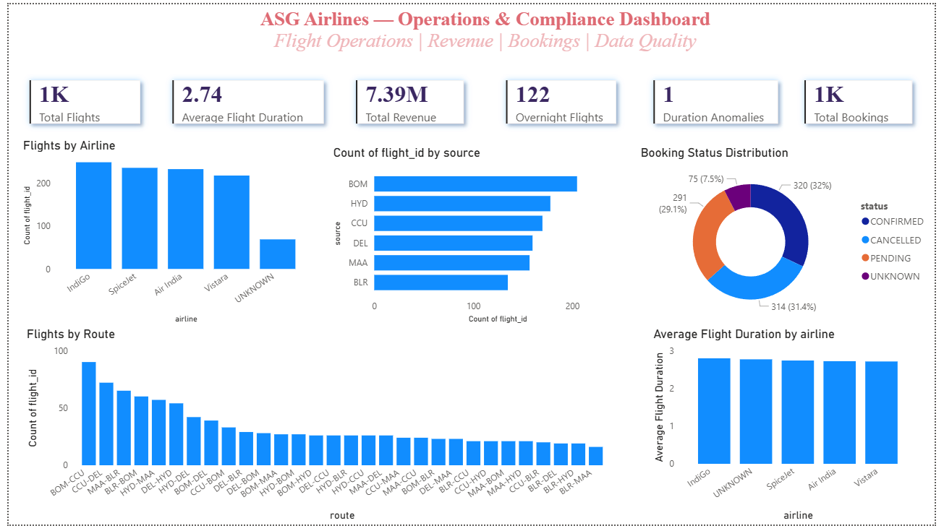Business Value
This page allows decision-makers to quickly understand the overall operational and commercial performance of the airline.

16. Dashboard Page 2 — Flight Duration Analysis
Subtitle:
Overnight Operations | Duration Anomalies | Route Performance
This page focuses on flight duration and operational anomalies.
KPIs
- Average Flight Duration
- Overnight Flights
- Duration Anomalies
Visualizations
- Average Flight Duration by Route
- Overnight vs Normal Flights
- Duration Anomaly Distribution
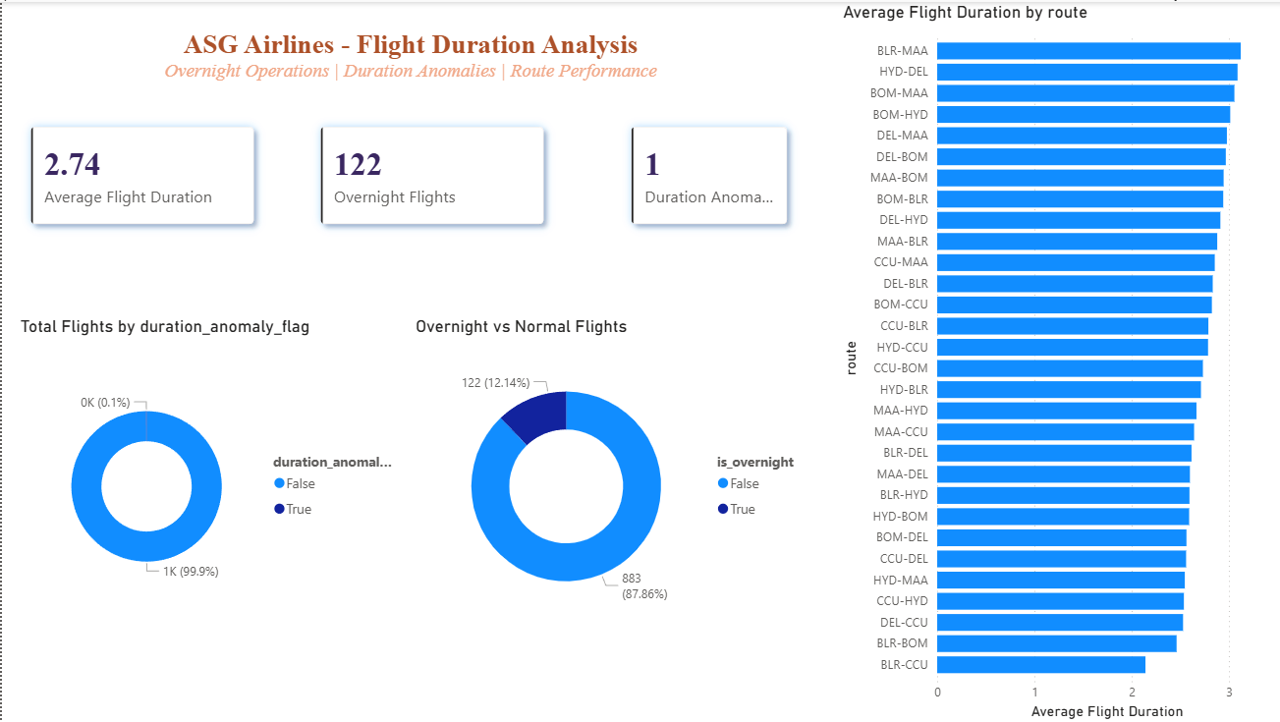Business Value
The page helps identify unusual flight durations and understand the impact of overnight operations.

17. Dashboard Page 3 — Route Performance
Subtitle:
Route Traffic | Airport Performance | Flight Duration
This page focuses on route-level and airport-level performance.
Visualizations
- Top Routes by Flight Volume
- Flights by Source Airport
- Flights by Destination Airport
- Average Flight Duration by Source Airport
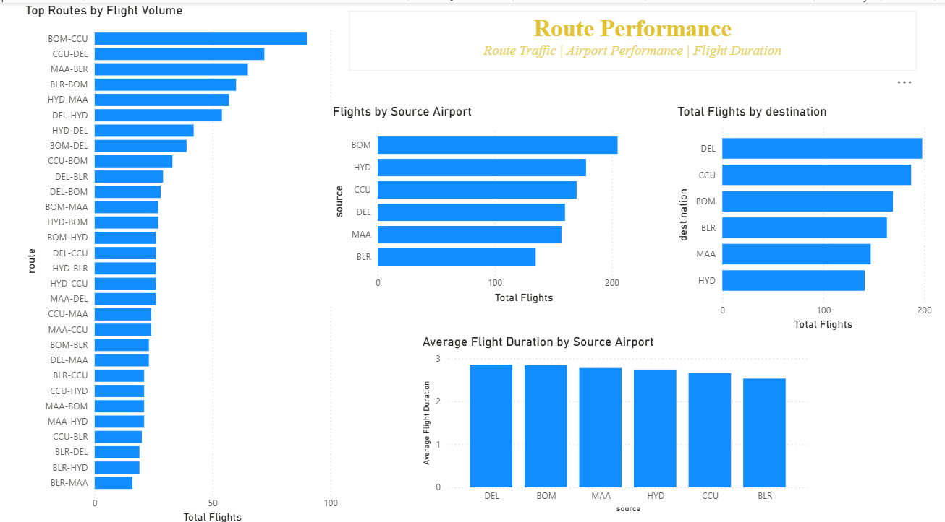Business Value
The analysis can help identify high-traffic routes and airports and support operational planning.

18. Dashboard Page 4 — Booking & Revenue Analysis
Subtitle:
Bookings | Revenue | Payment Methods | Booking Status
This page focuses on commercial performance.
KPIs
- Total Bookings
- Total Revenue
- Average Booking Value
Visualizations
- Revenue by Payment Method
- Booking Status Distribution
- Revenue by Airline
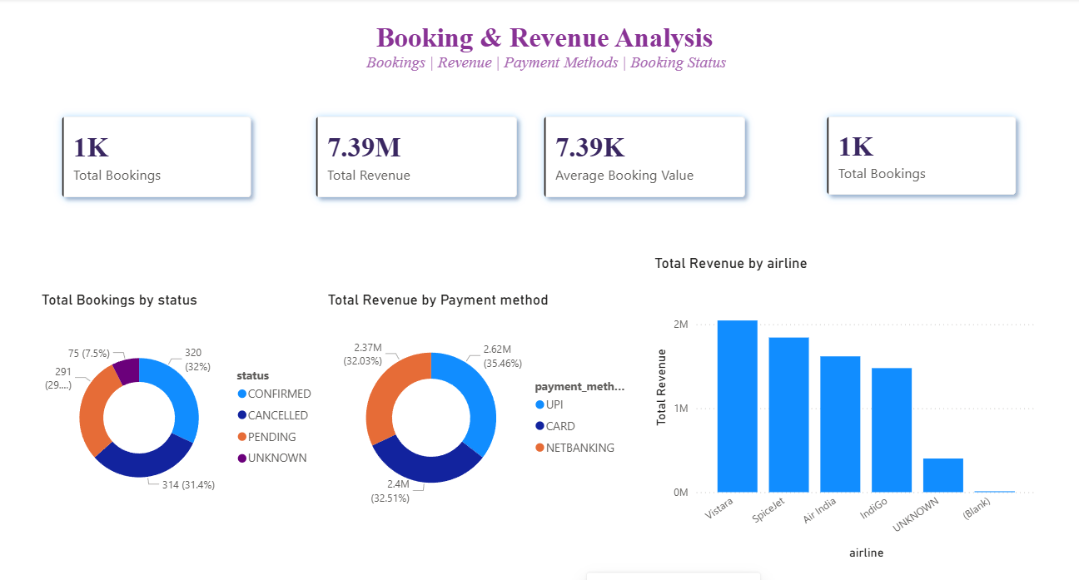Business Value
The page provides an overview of booking activity, revenue generation and payment behavior.

19. Scalability and Cloud Architecture
The current implementation uses Python and Jupyter Notebook because the assignment permits a local implementation.
However, the architecture can be migrated to Azure for larger-scale production processing.
A potential cloud architecture is:
Raw Excel / Source Data
↓
Azure Data Factory
↓
Azure Data Lake Storage
↓
Azure Databricks
↓
Data Cleaning & Transformation
↓
Curated Data Layer
↓
Azure Synapse Analytics
↓
Power BI
For production security:
Azure Key Vault
↓
Secrets / Credentials
↓
Data Pipeline
The cloud architecture is proposed as a scalable extension of the current solution rather than being represented as the local implementation.

20. Key Findings
The pipeline identified several important data-quality characteristics in the source data.
The analysis identified:
- 15 exact duplicate pairs
- 1 reused flight ID associated with 2 records
- 69 missing or unknown airline values
- 122 overnight flights
- 1 corrupted arrival date
- Flight duration values requiring recalculation
- Passenger identifier duplication requiring validation
- Duration anomalies requiring investigation
These findings demonstrate why data-quality processing is necessary before generating business KPIs.

21. Limitations
The project has several limitations.
Scheduled Flight Times
The available dataset does not contain reliable scheduled departure and arrival times. Therefore, actual flight delay cannot be calculated directly.
Instead, operational anomalies are represented through duration validation and anomaly detection.
Dataset Size
The current implementation is designed for the supplied dataset. For very large datasets, distributed processing through Azure Databricks or another scalable processing platform would be more appropriate.
External Data
The project does not currently incorporate external airport, weather or real-time flight data.
22. Conclusion
This project successfully implements an end-to-end airline data engineering workflow covering data ingestion, data-quality assessment, cleaning, transformation, validation, PII protection, analytical data preparation and visualization.
The pipeline converts raw and potentially inconsistent airline data into structured datasets suitable for business analysis.
Special attention was given to flight-duration accuracy, including flights crossing midnight, duplicate and conflicting identifiers, missing values, anomaly detection and passenger privacy.
The resulting cleaned dataset is connected to an interactive Power BI report containing four analytical pages covering executive performance, flight duration, route performance and booking and revenue analysis.
The solution also provides a clear pathway for migration to a scalable Azure-based architecture if required in a production environment.

